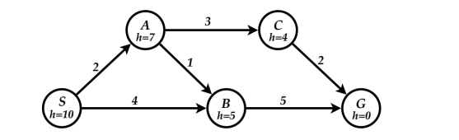

Greedy Best First Search

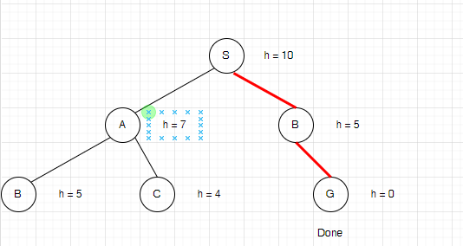

Path: S -> B -> G

A\* Search

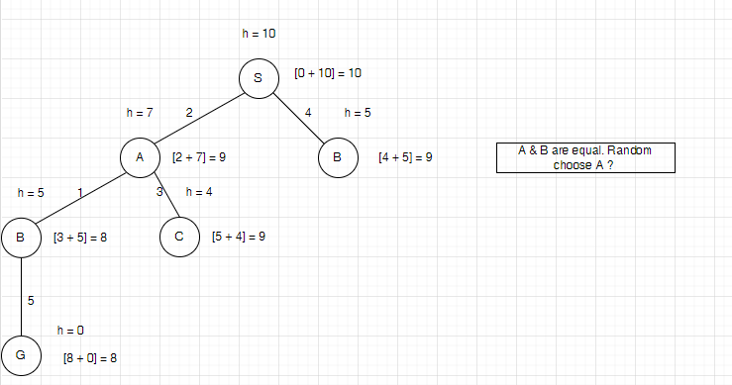

Path: S -> A -> B -> G